**Radiance T : Flow Diagram from Device to MQTT to Cloud**

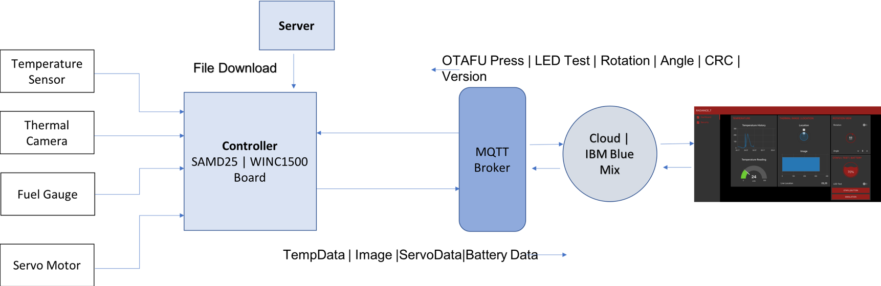

Message Transmission

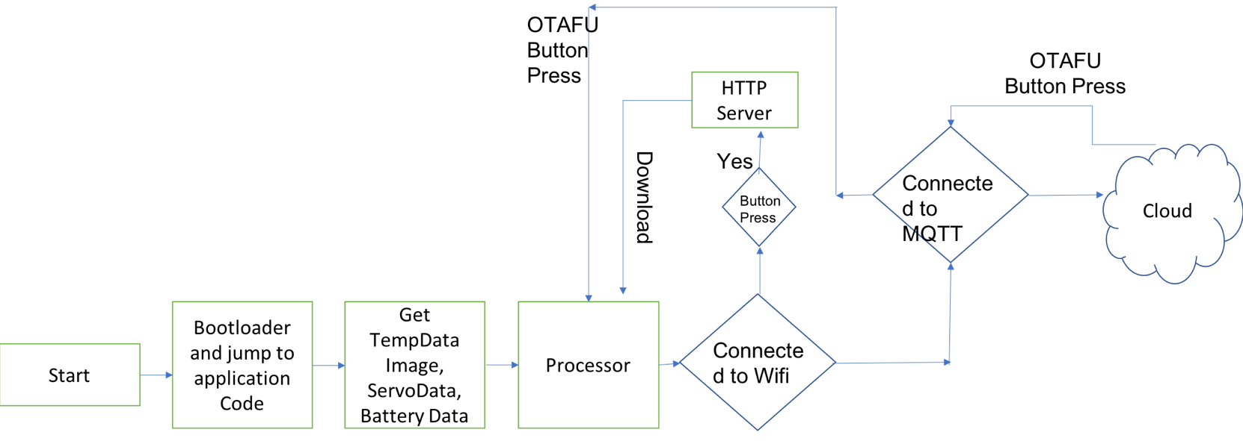

OTAFU Operation

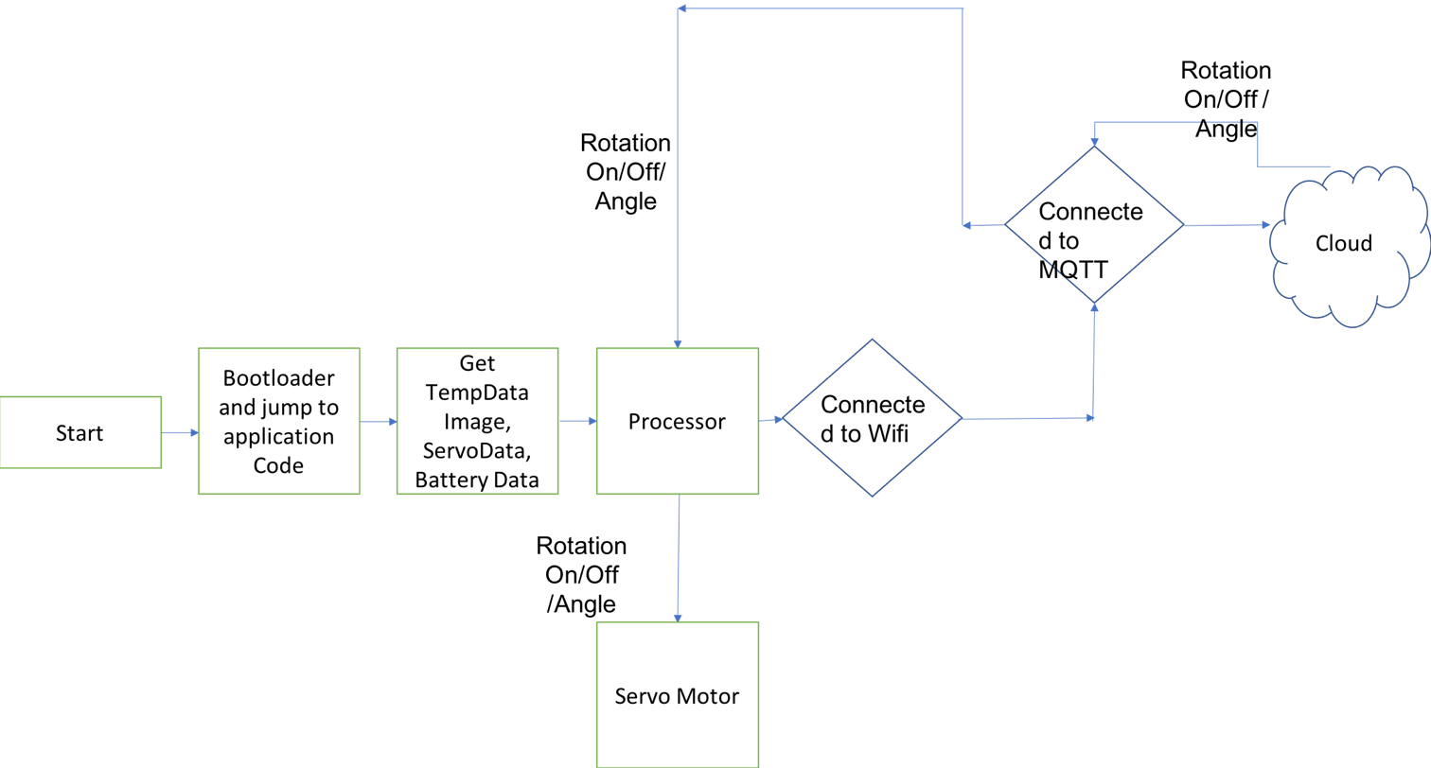

Servo Operation

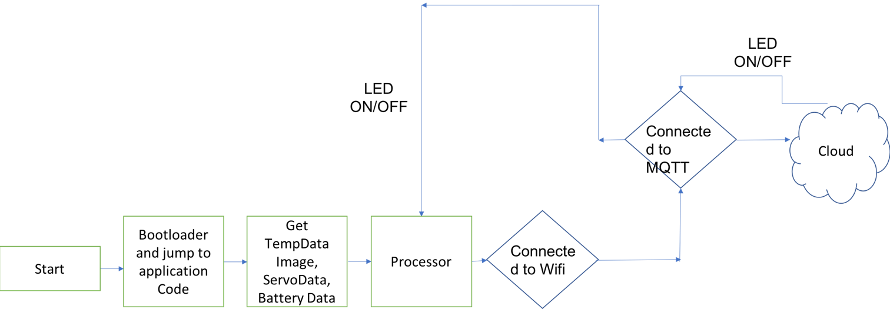

LED

Operation

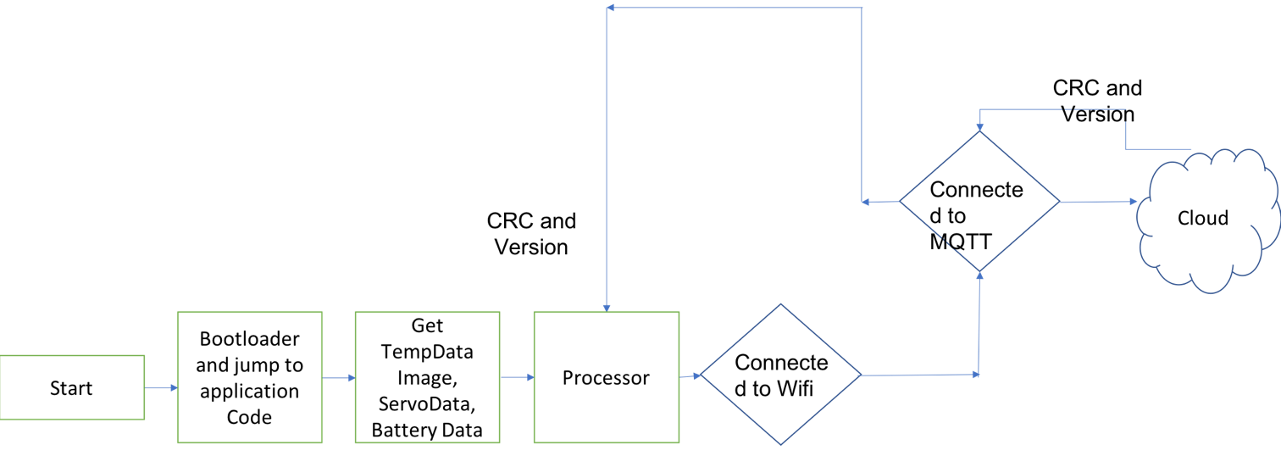

MetaData Trasfer